Instructions to authors for the preparation of papers for Slope Stability 2022
Author1 Company Affiliation, City, Country
Author2 Company Affiliation, City, Country
Author3, Author4 Company Affiliation, City, Country

Abstract
To achieve a uniform style throughout the Slope Stability 2022 proceedings, all papers are to be prepared according to the requirements contained within this template. Your paper should be limited to 12 pages. All papers must be submitted electronically by May 15, 2022 using the online submission feature on the symposium web site – e-mailed submissions will not be accepted. The corresponding authors of accepted abstracts can access the paper submission feature by logging in using their Username and Password registered during the abstract submission process.
Please ensure that your document meets the formatting guidelines before submitting. Do not submit your paper as a PDF as this limits the ability of the technical committee to correct any simple formatting errors. Final papers will be required to be submitted in PDF format in July, to be included in the symposium proceedings.

Introduction
Preference is for papers to be prepared using MS-Word. For easy formatting, use these instructions as a template by simply overwriting this text. Please prepare papers using “letter” paper size (215.9 mm by 279.4 mm / 8½ inch by 11 inch) and portrait orientation – A4 format is not acceptable. Please set your page for the following margin dimensions: top – 2.5 cm, bottom – 2.5 cm, left – 2.0 cm, right – 2.0 cm, and gutter - 0 cm. The header and footer settings should both be set at 0 mm from the edge. Do not insert page numbers or headers or footers.
The text is to be provided in a single column in Arial font. All text elements should be single-spaced. Paragraphs are not indented but are separated with 6 pt before and 6 pt after. Use style Normal. The text should be full justified.

Title, author block and abstract
The paper’s title should be typed at the top of the first page in 18 pt bold and left justified. Use sentence case (i.e., using upper case for only the first letter of the first word, not every word). Do not use all caps. Any proper nouns should be capitalized. The title should be set with 6 pt above and 24 pt after.
The author block should follow. Each author’s name(s) should be typed in 11 pt, left justified and in bold, followed by the author’s affiliation, city and country in italics. Each line in the author block should be set with 6 pt above and after. Please insert one open line after entering the last author’s affiliation.
Each paper must begin with an abstract, with a total word length that does not exceed 250 words. Type the word ABSTRACT in 14 pt bold (or use the Abstract Title style), with 18 pt spacing before and 6 pt spacing after. The abstract text should be in 11 pt font size and italicized. The abstract paragraph should be set with 6 pt spacing before and after.

Primary headings
Primary headings can be set using the ‘Heading 1’ style tag, or typed in 14 pt bold with 18 pt spacing before and 6 pt spacing after. A hanging indentation should be used, set to 0.95 cm. The heading text then follows with the 0.95 cm tab and left justified sentence case (capitalize only the first word).

Secondary headings
Secondary headings can also be set using the ‘Heading 2’ tag. Secondary headings should be in 12 pt bold font with 12 pt spacing before and 6 pt spacing after. A hanging indentation should be used, set to 0.95 cm. The heading text then follows with the 0.95 cm tab and left justified sentence case (capitalize only the first word).

Tertiary headings
Tertiary headings should be set using the ‘Heading 3’ tag. Tertiary headings should be in 11 pt bold italics font with 12 pt spacing before and 6 pt spacing after. A hanging indentation should be used, set to 1.5 cm. The heading text then follows with the 1.5 cm tab and left justified sentence case (capitalize only the first word).
Section headings should not extend beyond tertiary headings. If the section numbers do not properly update, then right click on the number and select ‘Set Numbering Value’. Then select ‘Continue from previous list’ and ‘Advance value’ and manually set the correct heading number.
Note that when a secondary or tertiary heading follows immediately after a higher level heading, as in the example shown below, the subsequent heading should be set with 0 pt spacing before.

Content

Text
Text paragraphs should be single-spaced and full justified, without any indentation. Paragraphs are separated Paragraphs are not indented but are separated with 6 pt before and 6 pt after. Use style ‘Normal’ from the styles menu.

Footnotes
The use of footnotes is discouraged. However, if they are absolutely required, footnotes are formatted as ‘Normal’ text paragraphs, single spaced, full justified, and are separated from the text above them by a thin (0.75 point) line 5 cm long. They should be inserted by selecting ‘Insert Footnote’ under the References tab in Word.

Figures
Figures including graphs, line drawings, photographs and other illustrations can be in either greyscale with sharp contrast or colour, with all lines and lettering large enough to be legible. All figures must be embedded in the document. Please number figures consecutively in the order of appearance and refer to them as Figure 1, Figures 2 to 4, (Fig. 5), and (Figs. 6-7).
Please use Format Picture, and selecting the layout tab, set the wrapping style to be ‘In Line with Text’. Figures should be centred, should not extend beyond the page margins and should be placed at the top or bottom of the page after they are referenced in the text (see Fig. 1). Do not place illustrations sideways on a page; however, if this cannot be avoided, no other text should appear on that page.
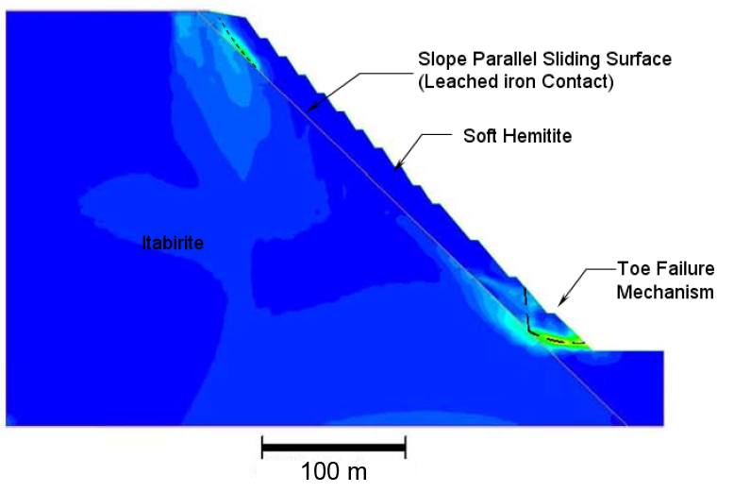
Figure 1. Caption text can be formatted using the ‘Figure Caption’ style, or use 11 pt Times New Roman font, full justified with 1.9 cm hanging tab, and with 8 pt spacing before and 18 pt spacing after.
Captions should be placed immediately below the illustration. Graphs, charts and spreadsheets copied from Microsoft Excel should be pasted as a picture or without links to Excel to ensure that the data are properly transferred into the Microsoft Word document. To ensure that your photographs and illustrations are properly converted from one computer to the next, convert them to JPEG, GIF and/or BMP files.

Tables
Number tables consecutively in order of appearance and locate them close to the first reference in the text, but such that the table fits entirely on the same page. Refer to tables as Table 1, Tables 2 and 3, (Table 4) and (Tables 5-6) in the body of the text. Avoid abbreviations in column headings (other than units).
Type the caption above the table, formatted as described below in the Table 1 caption. The table caption should be full justified, but the table can be centred. The table text should be 11 pt, left justified and non-bolded (‘Table text’ style tag) except for the text in the column headings, which should be bolded. Use the following example for the format of table.
Table 1. Caption text can be formatted using the ‘Table Caption’ style, or use 11 pt Times New Roman font, full justified with 1.9 cm hanging tab, and with 8 pt spacing before and 18 pt spacing after.
Geological Units | Density (kg/m³) | Young’s Modulus (GPa) | Cohesion (MPa) | Friction Angle (deg) | Tension (kPa)
Weathered rock | 2300 | 5.5 | 0.1 | 30 | 0
Rock mass | 2700 | 20.5 | 1.0 | 36 | 100

Equations
Center equations and formulas and number them consecutively. Simple mathematical expressions and sub - and super-scripted characters, such as SO₄²⁻, may be embedded in the text. Equation numbers should be placed flush at the right column margin in square brackets. This can be done automatically using the ‘Equations’ style tag.
Refer to equations in the body of the text by these numbers (e.g., "Eqn. [1]" or "Equation [1] shows..."). Symbols should be fully defined in the text.
Example of equation:
$σ_{1}^{'}= σ_{3}^{'}+C_{o} {\left(m_{b}\frac{σ_{3}^{'}}{C_{o}}+ s\right)}^{a}$ [1]

Cited References
Within the body of the text, references should be made in parenthesis with the author’s surname(s) and the year of publication such as “(Hoek et al. 2002)” or “According to Hoek et al. (2002)…”. References involving two authors should be separated by an ampersand (Hoek & Bray 1977), whereas those with three or more authors should give the first author’s name followed by ‘et al.’ (Read et al. 2009). Multiple references within parentheses should be separated by commas, for example “(Stacey 2008, Lorig et al. 1998a,b)”.
At the end of the paper, list all references in alphabetical order of authors’ names. References are formatted as a single-spaced, 10 pt font, fully-justified paragraph with a hanging indent of 1 cm (use style ‘References’). Do not leave an open line between references. Type book titles and the names of journals, reports and conferences, in italics.
In general, references should contain the last name and initials of all authors, the year in parentheses, the title of the paper, the name of the journal (italicized), the volume number, and the first and last page numbers. Reference to books should include the author, year in parentheses, title (italicized), and publisher’s name and location. References to edited books, conference proceedings, unpublished reports and other items should, in general, include the author, year, reference title, name of conference and city where conference took place, publisher and publisher city, and pages. Examples of various reference formats are presented below.
Because unpublished sources are often difficult to obtain, reference to them is not encouraged. Authors should strive to reference published material only.

References
Hoek, E. (1983). Strength of jointed rock masses. Géotechnique 33: 187–223.
Hoek, E., Carranza-Torres, C.T., Corkum, B. (2002). Hoek-Brown failure criterion - 2002 edition. In Hammah et al. (eds.), Proceedings of the Fifth North American Rock Mechanics Symposium, Toronto. University of Toronto Press, Toronto, pp. 267–273.
Karzulovic, A., Read, J. (2009). Rock mass model. In Read & Stacey (eds.), Guidelines for Open Pit Slope Design. CSIRO Publishing, Collingwood, pp. 83–139.
Read, J., Stacey, P. (2009). Guidelines for Open Pit Slope Design. CSIRO Publishing, Collingwood.

Clearances, copyrighted material and commercialism
All authors are responsible for obtaining written permission to profile the project or subject matter in their papers from any and all clients, owners or others who commissioned the work. The Slope Stability 2022 organizers assume that you have obtained the proper permission(s) and requires all corresponding authors to indicate their awareness of these requirements by indicating such in the online submission process when uploading your paper(s). The Organizing Committee assumes no liability for failure by the author(s) to gain proper permission.
If a figure, table or photograph has been published previously, authors must obtain written approval from the original publisher for it to be reprinted in the conference proceedings. The source of previously published material should be included in the caption of the table, figure or photograph.
All commercialism must be avoided. Products should be defined by their properties. Product names can only be used once within the paper and only where they are associated with the definition of the properties. Papers that do not conform will be returned to the author to be revised.
Providing an acknowledgment of sponsorship at the end of a paper is both appropriate and acceptable.

Footnotes must be located entirely within the page margins specified above.

